**NEPAL COLLEGE OF INFORMATION TECHNOLOGY**

**BALKUMARI LALITPUR**



**(Affiliated To Pokhara University)**

**SUBJECT : Database Management System**

**LAB REPORT # 2**

**TITLE :** Data Manipulation Language (DML) Commands

**Submitted By : Submitted To :**

**Name :** Pradip Dhungana **Name :** Amit K. Shrivastava

**Roll No :** 201751 **Department of Software**

**Semester :** 4th  **Date :** 2023/06/13

OBJECTIVE

To practice and Implement data manipulation language commands.

LAB EXERCISE :

* Creating a Database named ‘ncit’ and table called ‘employee’ with following structure :

|  |  |
| --- | --- |
| Column Name | DataType |
| e_id | int |
| e_name | varchar(20) |
| e_job | varchar(20) |
| e_salary | int |

= create database ncit;

= use ncit;

= create table employee(e_id INT NOT NULL,e_name VARCHAR(20) NOT NULL,e_job VARCHAR(20),e_salary INT NOT NULL);

OUTPUT :

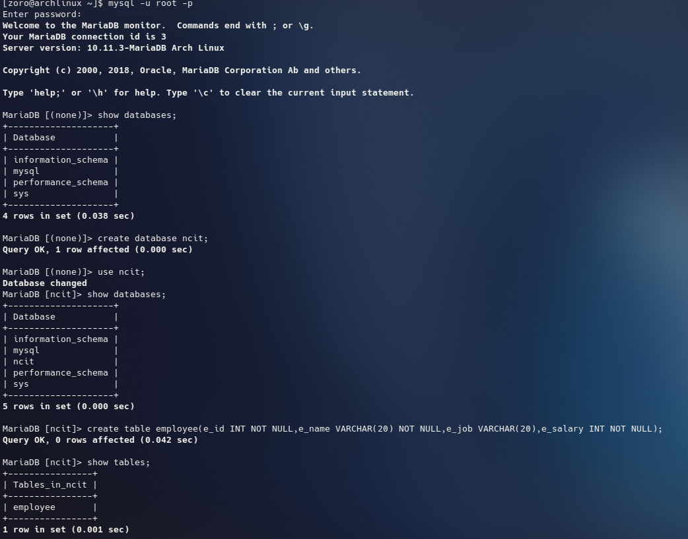

1) Insert a single record in employee table.

= INSERT into employee VALUES(1,'Pradip','mlEngineer',25000);

OUTPUT :

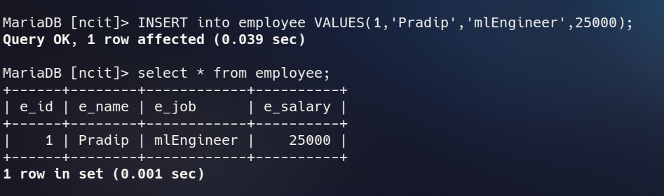

2) Insert more than one Record in employee table using a single insert command.

= INSERT into employee VALUES(2,'Prabin','analyst',20000),(3,'Bishnu','HoD',15000), (4,'Ujjwal','WebDevelopment',10000),(5,'Nischal','lecutrer',50000), (6,'Sabin','Programmer',20000),(7,'Pooja','Programmer',20000), (8,'Subash','Programmer',10000),(9,'Xaya','analyst',20000),(10,'Rajan','Designer',15000), (11,'Roshani','Designer',10000);

OUTPUT :

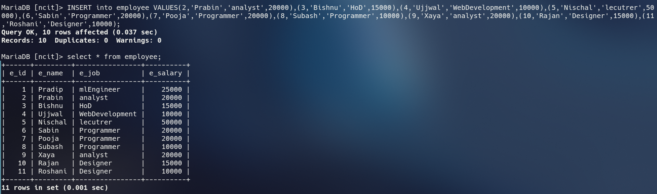

3) Update the employee table to set salary of all employees to Rs. 25,000 who is working as programmer.

= UPDATE employee SET e_salary='25000' WHERE e_job='programmer';

OUTPUT :

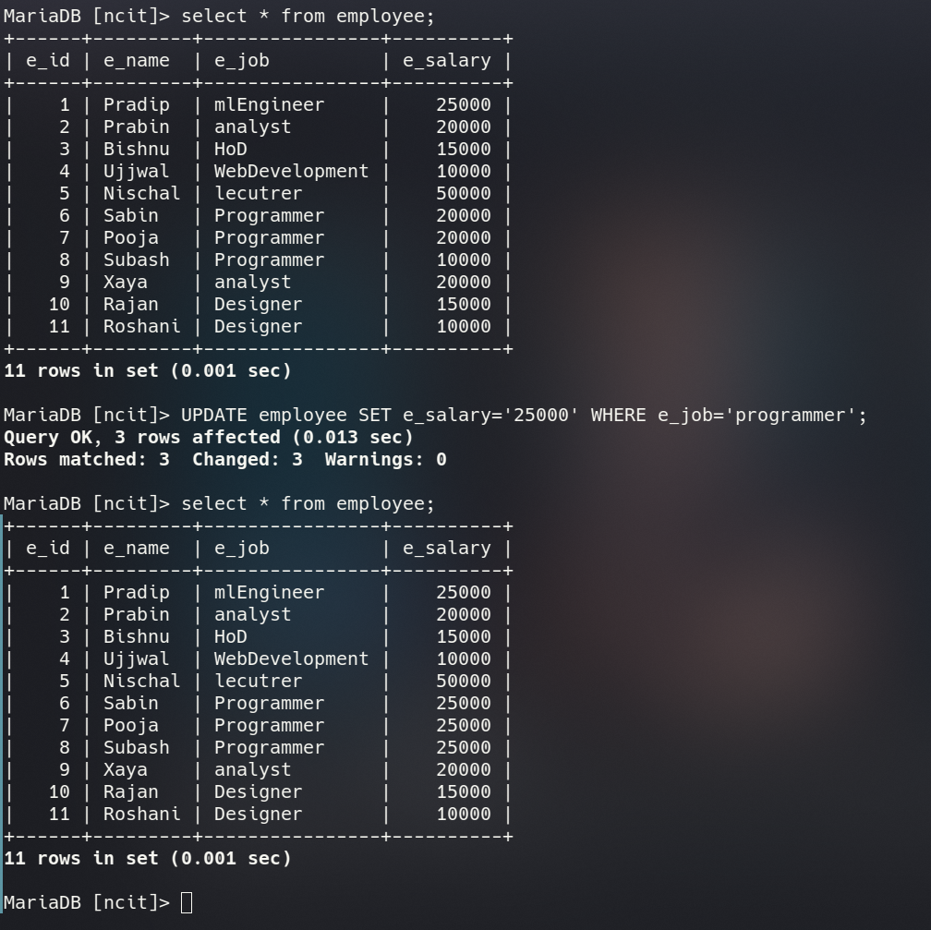

4) Select all information from employee table.

= select * from employee;

OUTPUT :

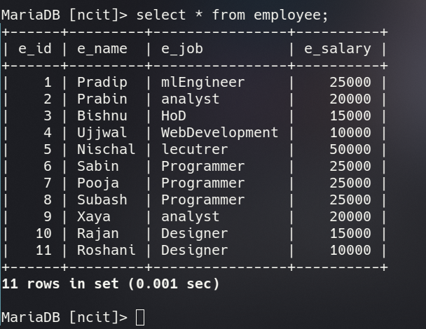

5) Select employee name and job from employee table.

= SELECT e_name,e_job FROM employee;

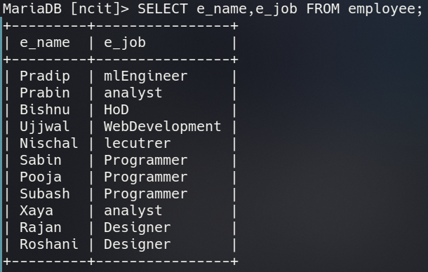OUTPUT :

6) Delete those who are working as designer.

= DELETE FROM employee where e_job='Designer';

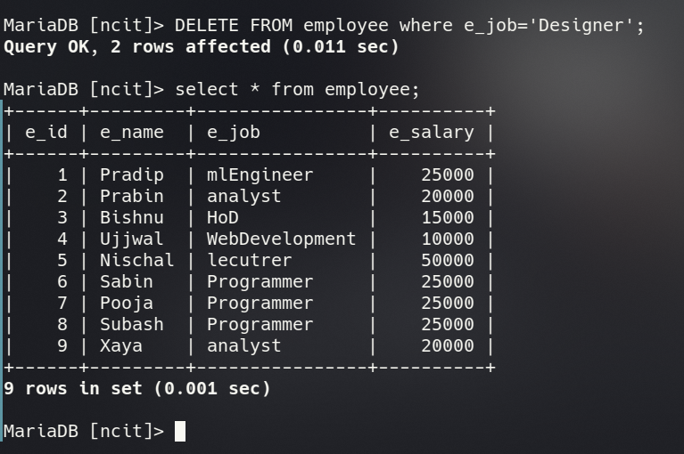OUTPUT :

7) Display only those employees who work as analyst.

= SELECT * FROM employee WHERE e_job='analyst';

OUTPUT :

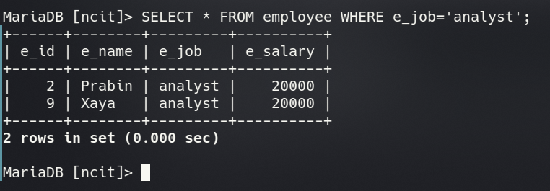

8) Display employee job from table avoiding duplicate values.

= SELECT DISTINCT e_job FROM employee;

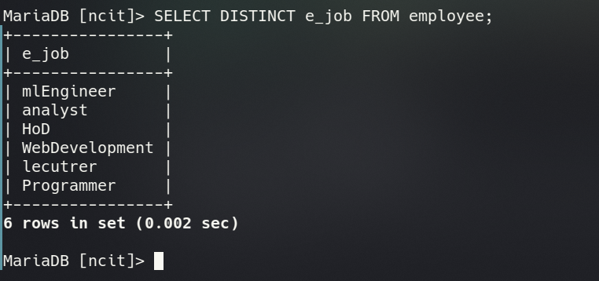OUTPUT:

9) Display employee name and job from table whose salary is greater than equal to 20,000.

= SELECT e_name,e_job FROM employee WHERE e_salary>='20000';

OUTPUT :

